

DSD LAB RECORD

Software



Sidak singh (24BCE1460)

AKshit madathil (24bce5304)

Niketh (24bai1600)

SHAASVAT R (24BAI1612)

PRAJWAN

Experiment – 1

Verification of Boole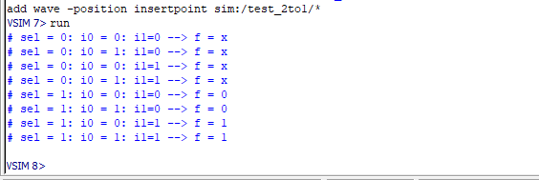an expression

* Aim-

To verify the given Boolean expression using Model Sim software.

Y=AB

* Tools Required-

Model Sim software

* Code-

Design block code-

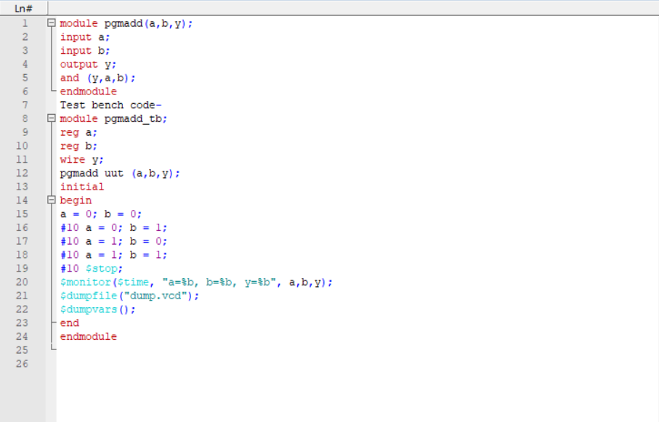

* Circuit Diagram-

* Truth Table-

|  |  |  |
| --- | --- | --- |
| A | B | Y |
| 0 | 0 | 0 |
| 0 | 1 | 0 |
| 1 | 0 | 0 |
| 1 | 1 | 1 |

* Output-

* Result-

Hence the given Boolean expression has been verified.

Experiment – 2

Implementation of Adder and subtractor Circuits

* Aim-

To develop the source code for adders and subtractors by using VERILOG (Modelsim) and obtain the simulation.

* Tools Required- Model Sim software
* Half Adder:

i)circuit diagram:

ii)code:

Design block -

Test bench -

iii)Output:

* Half Subtractor:

i)Circuit diagram:

ii)code:

Design block-

Test bench-

iii)Output:

* Full adder:

i)circuit diagram:

ii)code:

Design block-

Test bench-

iii)Output:

* Full subtractor:

i)circuit diagram:

iii)code:

Design block-

Test bench-

iii)Output:

* Result-

Hence the adders and subtractors have been implemented

Experiment – 3

Design of Decoders

* Aim:

To design and implement Decoder circuit using VERILOG(Modelsim) and obtain the simulation.

* Tools Required: Model Sim Software.

2:4 Decoder:

i)Circuit Diagram:

ii)Code:

Data Flow:

Behavioural modelling:

Test Bench:

iii)Truth Table:

|  |  |  |  |  |  |
| --- | --- | --- | --- | --- | --- |
| A1 | A0 | Y0 | Y1 | Y2 | Y3 |
| 0 | 0 | D | 0 | 0 | 0 |
| 0 | 1 | 0 | D | 0 | 0 |
| 1 | 0 | 0 | 0 | D | 0 |
| 1 | 1 | 0 | 0 | 0 | D |

* Output:



* Result:

Hence decoder is designed.

Experiment – 4

Design and Implementation of Multiplexers

* AIM:

To verify and study the truth table of 2:1 multiplexer circuit using modelism

* SOFTWARE REQUIRED: MODELISM
* CIRCUIT DIAGRAM:

* CODE:

GATE LEVEL MODELING:

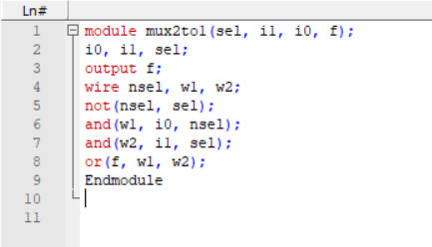

TEST BENCH:

DATA FLOW: module mux2to1

TRUTH TABLE:

|  |  |  |  |
| --- | --- | --- | --- |
| SELECT(S) | INPUT(A) | INPUT(B) | OUTPUT(F) |
| 0 | 0 | 0 | 0 |
| 0 | 0 | 1 | 0 |
| 0 | 1 | 0 | 1 |
| 0 | 1 | 1 | 1 |
| 1 | 0 | 0 | 0 |
| 1 | 0 | 1 | 1 |
| 1 | 1 | 0 | 0 |
| 1 | 1 | 1 | 1 |

* RESULT: The multiplexer was successfully designed and implemented in ModelSim using basic logic gates, and its functionality was verified with the truth table.

Experiment – 5

1(Bit) magnitude comparator

* Aim- To verify the 1(Bit) magnitude comparator using Modelsim software.
* Tools required- Modelsim software
* Circuit Diagram-

* Code-

Design block code-

Test bench-

* Truth Table-

|  |  |  |  |  |
| --- | --- | --- | --- | --- |
| A | B | A>B | A=B | A<B |
| 0 | 0 | 0 | 1 | 0 |
| 0 | 1 | 0 | 0 | 1 |
| 1 | 0 | 1 | 0 | 0 |
| 1 | 1 | 0 | 1 | 0 |

* Output-

* Result-

Thus the 1(Bit) magnitude comparator has been verified.